Weather phenomena
This book is about weather as a system. The purpose of the book is to connect various weather phenomena into a weather system. Earth's weather system is composed of many interacting pieces. Huge changes in weather can occur in minutes or span decades. Weather's breadth is large because the details can involve components that vary in size from molecules to an entire planetary system. The complexity of weather spans most of human scientific knowledge. Weather can be frightening and it can be beautiful. The components of weather interact in many obvious and some not-so-obvious ways. Weather is complicated due to the quantity and interaction of processes. And yet, weather is as simple as sun, air and water. Most disconcerting of all, weather can be counter-intuitive.
Okay, I've built up this imposing monolith of complexity, potential beauty and impending doom. Is it even possible to understand weather? Yes! We can, but, like every complex system you break it down into its simplest components, analyze them, test their interactions with other components and model how they interact with other components. Then you can determine how they fit into the totality of the system and create an interface that encapsulates the properties that influence them and, in turn, they influence. This is how we understand complicated systems and it is how we create simulations. Some consider system analysis and simulation as different skill sets, but the approach is the same. Divide, understand, reconstruct, conquer and test, test, test.
Literally, the same people that put the first men on the moon were my mentors. That is how they did it. They examined each piece individually and determined how those pieces fit together. They then created a diagram of the interactions and assigned tasks. Block by block they created a model of one of the most complicated system ever built on earth. They used typewriter, pencils, erasers, four function calculators and normal office tools. They not only didn't have computers, they didn't even have post-it notes.
We can build a weather system model and simulation if we remember a few basic truths, a test (demonstration) is worth a thousand opinions and sometimes the most important insights come from a kid shouting about clothes.
The bottom line here is that if we really believe we can understand weather, then we should be able to simulate it. To simulate weather, we must break it into its constituent components and 'black box' them to allow interaction between those components. The first two black boxes are vertical weather and horizontal weather.
Gravity drives vertical weather. Vertical weather is usually limited to local effects such as thunderstorms, gentle breezes, offshore breezes and tornados.
Horizontal weather is driven by a horizontal force based on centrifugal force, but highly modified to accommodate earth's spherical shape. The concept is new but the math is relatively simple. The mathematical model of the force derived from centrifugal force is TWF the force that drives weather horizontally.
This book introduced some of the individual concepts earlier. This section of the book is to give a glimpse how these concepts work together to form a global weather system. Once we understand the building blocks, we can model them. Once we model them, we can simulate them. Once we can simulate them, we can understand them much better.
Many of the building blocks will be familiar but presented in a different manner, while other building blocks provide a few of the missing pieces to build a complete weather system.
The body of the book develops these concepts and theories in depth.

Evolution of weather understanding
Before man began recording his progress for future generations, everyone that looked at the sky saw clouds, the sun, the moon, the stars, a blue background in the daytime and a black background at night.
Early societies considered the elders, witches, medicine men or the equivalent in various societies as the first scientists. The ancient saying,
Red sky at night, sailor's delight.
Red sky in morning, sailors take warning,
was likely true on the Mediterranean where a morning red sky meant the most recent front had passed you to the east. In contrast, to a sailor traveling in the Atlantic trade winds a red morning sky might signal an impending hurricane from off the African coast.
The written word began the process of passing knowledge accurately and to larger numbers of people. Numbering systems were a giant step allowing comparison of successive years and providing improved predictive capability, however primitive.
As the number of recorded observations increased, man was able to refine their theories of how weather worked primarily through comparison of the observations. Beginning with obvious observations, such as 'snow occurs in winter', our knowledge expanded by such developments as calendars, astronomical theories, timepieces and, eventually fluid dynamics and thermodynamics. Each generation improved the state of the art. The mark of progress in any science is the available tools.

Stagnation of weather understanding
This is going to sound harsh, but weather as a science has been stagnant for over a century. Good people have done good work in specific specialties, but much of that work was based on a foundation of quicksand.
The ancient Greeks advanced weather theories and as with nearly all their ideas, they were wrong, but they established a foundation for future development. We should most respect those that begin with a white sheet of paper. Even the ancients knew the sun's radiant heat is the source of changes in the atmosphere.
The geography of how, where and when the sun heats the earth's surface and atmosphere is the primary consideration when describing weather. A second important consideration is earth's topology. Geography is important because it provides the dividing lines between land and water. Topology is important because it directly affects airflow direction and water availability. Solar insolation, geography and topology are all fixed.
After energy availability, water availability is the primary variable deriving the characteristics, location and intensity of weather.
Everyone agrees that water comes from the oceans. This section is about some specifics regarding water transported from the oceans onto land. Much of this book is devoted to unusual and dangerous weather. But to understand the exceptions, you must understand the rules.
The most important factor affecting life on Earth is how energy facilitates the movement of life giving water. The mechanism moving water the tropics to the Polar Regions is Tangential Weather Force powered weather fronts. The result of TWF acting on the atmosphere is the worldwide air circulation system we will refer to as Hunt circulation. We will discuss that in detail later.
First we will discuss diurnal westward moisture pumping as vertical (gravity driven) weather mimics horizontal TWF.

Extreme weather
Letting the devastation of catastrophic weather events overwhelm one is easy, it happened to me. Sensational weather effects such as tornados and hurricanes get a lot of attention from the general public and rightly so. 'Average' people are isolated from daily weather with clothing, transportation and living accommodations. A few people such as pilots, farmers, truckers or construction workers have no buffer from the weather. For those folks weather events that most people would not notice can be ruinous or catastrophic. Airplane pilots risk their lives daily depending on their knowledge of weather. Farmers' entire lives can be wonderful or tragic depending on monthly weather whims. The entire planet's future depends on fractional annual temperature rise.
The original impetus for this theory was a desire to understand tornados. Current weather theories were inadequate to explain even simple atmospheric vortices such as dust devils. A dust devil is a close cousin of any other vertical axis atmospheric vortex. Magnitude and energy sources are all that separate the dust devil from the F5 tornado and even the mighty hurricane. Even after a rudimentary tornado genesis theory was established, there was still a need to understand cluster tornados.
A chapter on tornados is included explaining all the components of a tornado. The chapter explains how these components work together to generate the cute little dust devil and monster supercell tornado. However, that theory is inadequate to explain the rare cluster tornados arrive in dozens for a day or two. A theory explaining continental scale atmospheric movement was necessary to explain cluster tornados, the original impetus for the research.
Having a working theory for tornado genesis made it obvious that cluster tornados were associated with weather fronts. But how can you trust a theory about weather fronts that doesn't explain the reasons for fronts, tomorrow's rain or sun, droughts, floods, deserts and many other weather phenomena arising from front generation and movement?
Don't get me wrong the current state of weather research makes air travel, space travel, daily weather awareness and long-term trend predictions possible. We know days in advance about temperature trends and hurricanes. Current weather technology also saves many lives each year because we know about tornados and floods minutes and hours in advance. Weather technology has even added minute-to-minute weather evaluation tools to aircraft making commercial air travel safer.
It was necessary to understand continental scale weather. Tangential Weather Force (TWF) is the solution to the planet's continental scale weather events. TWF theory is a guide to understand general weather systems and weather fronts along with their associated low-pressure areas.
Hurricanes are another topic discussed in detail here. The hurricane center in Biscayne, Florida will patiently explain how water temperatures affect the occurrence and intensity of hurricanes. I can assure you that the water under a hurricane's cloud cap has nothing to do with storm strength and water strength in the Gulf of Mexico has never, ever increased a hurricane's strength.
Therefore, I've decided to start this book with a discussion of the everyday process of diurnal (daily) transport of water from the oceans to the interior of continents. The diurnal process of pumping water from the water masses on east coasts toward the west coast of landmasses is a simple exercise in solar heating and water transport. But it is not so simple that I have found it documented elsewhere.
Later I will discuss another important mechanism of moving huge amounts of water from the tropics to the northwest portion of continents in the section on Horizontal Weather.
Together these water movements distribute water to support life and equalize the planet's thermal profile by cooling the tropics and warming the Polar Regions.

Diurnal (daily) weather fronts
The study of Earth's weather is an examination of how the sun, ocean, land and air affect water. The first step in understanding earth's weather is how water moves onto continents from the oceans. The irony here is that diurnal east-to-west water pumping closely resembles early meridional theories I so vehemently deny. The difference is that this model identifies a real force that moves the moisture west, differential heating of water and air.

Fronts
A front is a giant mass of air moving from one location to another. Cold fronts dominate United States weather. They move from the northwest to the southeast. North America's geography determines the path, which is dominated by north-south aligned mountains creating a northwest to southeast corridor.
Whenever there is a shear line between buoyant air and dense air, the buoyant air will resist mixing with the dense air until the velocity gradient on the buoyant-air side becomes too great near the shear wall and the two fluids begin to mix. The flow is always out of the buoyant air region into the dense air region and is always composed of both dense and buoyant air. The result is an eddy. Contemporary weather broadcasters refer to them as lows or low-pressure areas. Eddies are the precursors of cyclones and share a number of characteristics. Like cyclones, these eddies allow intrusion from only one area around the periphery inhibiting flow through their area. The result is an effective barrier to air flow in the body of the eddy.
Northbound air is always buoyant, and southbound air is always dense. Therefore, low- pressure areas always develop from the buoyant-air side into the high-pressure side. Among other things, eddy development creates the periodic nature of air movement.
These air movements are periodic instead of steady and arrive as 'puffs' of air that might last for hours or days. Usually, a front doesn't consist of a vertical wall of air but rather a wave of air building up to a crescendo and tapering off to wait for the next flow, much like an ocean wave. During solstice, when the atmosphere is relatively quiet, fronts tend to be less dramatic. During equinox, when the atmosphere is experiencing its greatest change between seasons, the fronts tend to be more dramatic.

Daily weather fronts
The previous section briefly discussed TWF or continental size weather fronts created by horizontal forces. Vertical weather can mimic horizontal weather producing local fronts. An example is the east to west humidity pump driven by coastal breezes.
Coastal breezes are reliable diurnal (daily) events, which are more effective on the east coast of landmasses. Over-water and over-land air temperatures equalize during the night. At sunrise glare limits energy captured by water maximizing heat captured by land. The heat energy captured over-land transfers to the air by temperature and seasonally by plant life. Over-land air heats quickly while over-water air heats slowly. Over-land air becomes buoyant and is displaced vertically by over-water air creating an on-shore (from the water surface to the land surface) breeze. Because of surface area differences and plant respiration and photosynthesis over-land humidity is greater in over-land air. These morning and afternoon breezes can become quite brisk.
Summary: Daily breezes move humidity vertically and inland due to convective and organic changes in air buoyancy. This creates a continuous flow of moisture-laden air from the water over land. The east to west water to land orientation is important because glare reduces water heating when the sun is first rising. There is reduced differential solar heating resulting in a net-sum-gain. (no sun gain?) This is the mechanism that creates luscious green eastern coasts on land masses.
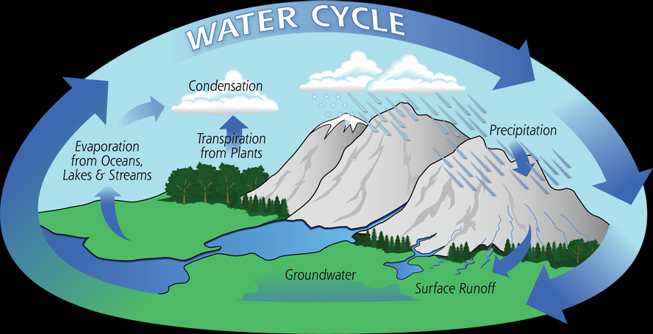
We've all seen stylized drawings of water flowing down from mountains into steams then rivers and rain back to the low lands where it evaporates to provide rain to the mountains. The illustration inserted here is from NASA. Since the ocean is on the left we must assume this is either a drawing looking southward toward the equator in the northern hemisphere or near the equator looking northward in the southern hemisphere. Diurnal (daily) moisture movement is from the rising sun toward the setting sun.
A glance at a global map shows that the west coast of all continents is arid (desert) while the east coast is lush. In other words, if one looked at a satellite picture of the earth without clouds, they might note that the western shores of continents are deserts and the eastern shores have more than adequate moisture to support vegetation. This is one reason for western deserts.
More details are available in the section on Diurnal moisture pump.

TWF atmospheric moisture movement
The oceans have consistent circular (triangular actually) air movement. Warm moist buoyant air moves from the ocean's western shores toward the polar areas. As the air moves toward the poles, it becomes cold, dry dense air. Because cooling and moisture loss increases its density, it then begins its cyclical move toward the tropics until it nears the solar equator. At the southern extent of its southeast voyage the air veers east and west with the westbound air returning to its point of origin.
In the northern hemisphere moisture from the southwestern corner of the Atlantic from Southeast Asia condenses as rain in places like England and Washington State respectively making those northeastern ocean coasts lush. Condensation due to polar cooling of northeast-bound buoyant air is the source of that rain. As the air moves down those ocean coasts it continues to dry becoming air in such places the southwestern United States, northwestern Africa, Peru and Australia. Australia's eastern mountain ranges create a nationwide desert because they block the east to west diurnal water pump.
To recap, the oceanic airflow's second leg from Polar Regions to the tropics have two zones. Above and around about 40° latitude, air is cooling and drying. The cooling causes precipitation making those areas lush. Below about 40° latitude, air is warming but still dry. Between about 40 degrees latitude and 30° latitude, the still cool air from the northwest is dry.
That is why Washington State is a cold rain forest and Southern California is, excuse me was, an arid wasteland.
Believe it or not, science IS fun! But the pay is not so hot.

Creation of doubt
Few people believe government information is reliable for subjects they understand.
I claim to have a superior weather system theory, which cost me a few thousand dollars to create. I now must convince you that government sponsored weather theories that costing $Billions are inferior.
In other words, I will have to create doubt about the NASA and NOAA interpretations of weather effects and sources. As I said before NASA and NOAA have done exemplary work with the tools they have available. This theory presents them with a brand new shiny box of tools.
However, don't believe for a second that those in management levels of government weather research will accept these new theories gracefully. They are the ones that spent the $billions.

Hurricane dynamics - Helene
Consider 2024 hurricane Helene that dropped so much water on Western North Carolina in such a short time. I could tell you that NOAA estimates 40 trillion gallons fell from Hurricane Helene. Let's accept that value for now. Let's just see how accurate that estimate may be.
$$4 X {10}^{10}*0.1337 \frac{{ft}^{3}}{gal}=5.34 X {10}^{9} {ft}^{3}$$
Let's see what size cube that would fill
$$\sqrt[3]{5.34 X {10}^{9} {ft}^{3}}= 1,749 ft per side$$
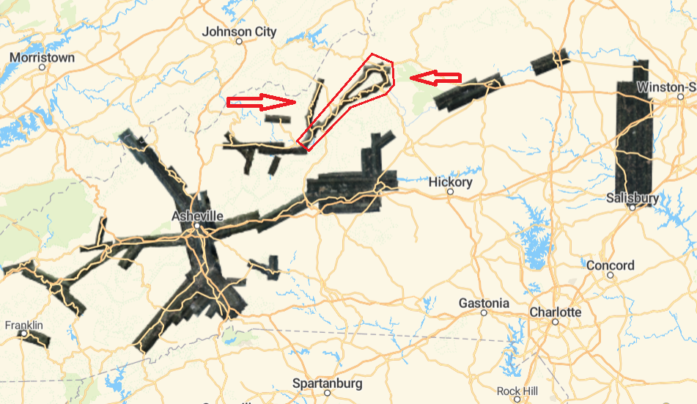
A cube containing $4 X {10}^{10} gal$ is 1,749 feet on a side! I bet you expected that to be larger. The thing about electronics folks is we are use to working with extremely large and extremely small numbers.
I'm going to estimate the standing floodwater in one little patch of North Carolina. I've marked it in red. It is two hollows created by two small rivers.
The most severely flooded areas followed highways. In the mountains (and hills), highways follow rivers or streams because water seeks the shortest route to earth's geometric center. This is the same criteria for least expensive road development. Tourists follow the roads, which is why so much developed property was involved in the flooding. My youth was (mis) spent about 200 miles away on the Tennessee side of the mountain.
The route between Boone, NC and Spruce Pine, NC is 37.7 miles according to Google Maps. The Watauga River runs north from Enviroguard, NC to Boone, NC. The Linville River runs south with its origin near the Watauga River origin.
First, we'll divide the volume in cubic feet by the river's channel length in feet giving the cross sectional area necessary to hold 40Billion gallons of water.
$$\frac{5.34 X {10}^{9} {ft}^{3}}{37.7 mi*5,280 \frac{ft}{mi}}=2.68 X {10}^{4}{ft}^{2}$$
A channel 37.7 miles long would have to average cross section of $2.68 X {10}^{4}{ft}^{2}$ to hold 40 Trillion gallons. If we assume a water depth of 35' then
$$\frac{2.68 X {10}^{4}{ft}^{2}}{35'}={766}^{'}$$
A single 37.7 mile long small river section with an average water depth of 35' and average valley width of 766' will 40 Trillion gallons. When you count the area in the creek mouths, wide spots and deep water backup behind gorges (narrow sections of canyons) 40 Trillion gallons of standing water is a reasonable volume.
Now when you consider the flowing water from the watershed in that small area alone was significantly greater than 40Trillion gallons.
Being from the area, I know that the area I selected for the calculation is upstream of Watauga Lake behind the Watauga Dam. It has a flood storage capacity of 152,829 acre-feet (49.7 billion gallons) in its 16-mile length and with its average depth of 52.5 feet.
Believe it or not, I did all these calculations to talk about weather radars! I am guessing that the 40trillion gallon value was a result of a radar calculation. Radar has a real problem in heavy rain. A RADAR set sends out a pulse of RF energy and measures how long it takes to return for distance and measures the return amplitude (strength) return signal for rain intensity. A large portion of the transmitted radar energy is absorbed and instead reflected back to the radar set in heavy rain. Therefore, there is no way to 'see' what is behind heavy rain.
The North Carolina storm was in the mountains above 2,000 feet and surrounded by 3,000 to 5,000' mountains. The atmosphere transports rain lower altitudes. To pass through the mountains of western North Carolina the atmosphere experienced a significant increase in altitude. When the atmosphere rises, its temperature drops causing rain. Ashville is large because major roads were built in the most convenient places for construction and Asheville's altitude is about 2,100' and surrounded by mountains on all sides.
Radar measures rainfall by return amplitude and nearly all the rain was below the mountaintops. The radar can only report what it sees and the falling rain was hundreds of feet below what radar could 'see.' The amount of reported rain in western North Carolina was greatly under-estimated for these reasons, if rainfall estimates were from radar imaging.
That was a lot of work to complain about radar estimates of bad weather but the point is important. There are many shortcomings in both radar and satellite weather reporting. I get into detail later in the book.
Keep in mind that the broadcast industry and federal weather reporting institutions have interest in maintaining faith in radar and satellite reporting methodology. This is not an attack on either. They are wonderful and have saved huge amounts of lives and property over the decades. But their limitations should be noted so we (the public) can be aware of their shortcomings.

Local moisture and storm moisture
NOAA/NASA literature states that increased water temperature in the Gulf of Mexico powers hurricanes initiated in the Gulf of Mexico. You might think that since I'm trying to promote an alternative theory, I'll have to take a different route. I'm going to take a different route because it is the only one arriving at the destination.
As an engineer, I studied thermal interaction, liquid-gas evaporation interface, energy exchange and gas-liquid condensation. All of those thermodynamic interactions occur in the little HVAC box that provides heating and cooling for homes. That's right, the basic operation of hurricane (indeed all weather effects) is the same as your HVAC, except that the fluid is water instead of refrigerant.
The temperature of the water in the Gulf of Mexico is in the 90's, the temperature of the air in the Gulf of Mexico is in the 90's. How will 6" of water evaporate in three days with an air/water temperature differential of less than 5 degrees? Short answer, it can't. The numbers are not there. Just one fact should dissuade you of that notion. Hurricanes create clouds. Clouds obscure the water from solar energy. Thus, all the potential energy to evaporate water is cut off as soon as the hurricane forms or even approaches.
Consider the water dumped on 300 miles of Georgia and 100 miles of North Carolina more than a foot of rain in some places. Where did that water originate? It didn't come from Florida, Georgia or North Carolina.
A popular persistent misconception about relative humidity is that 10% humidity means 10% of the air is water. If that were true, then 100% humidity would mean that the atmosphere was all water. Atmosphere with 100% humidity is 99.65% air and 0.35% water by weight. That's right, 100% humidity is one third of one percent water by weight.
Just for shiggles lets say the atmosphere above a square foot of ocean was saturated with 100% humidity. That would be all the way from sea level to the atmosphere. Obviously the column of air above one square feet of ocean would weigh 14.7 pounds.
$$14.7 lb* .0035\frac{{lb}_{H_{2}O}}{{lb}_{air}}= .0515lb*16\frac{oz}{lb}= 0.82 oz H_{2}O$$
Water's mass is 62.4 lb per cubic foot
$$62.4\frac{lb}{{ft}^{3}}*16 \frac{oz}{lb}=998 \frac{oz}{{ft}^{3}}$$
Volume would be
$$\frac{0.82 oz H_{2}O}{998 \frac{oz}{{ft}^{3}}}= 0.00082 {ft}^{3}* 12\text{= 0.0098" }H_{2}O$$
Each square foot of atmosphere only contains about 0.01" of water MAXIMUM. Generally speaking, all the atmosphere's water is in the bottom half of the atmosphere so it's more like 1/20 of an inch. So it is safe to say that the water that fell on North Carolina from hurricane Helene did not arrive as humidity.
Clouds are water droplets in air and water droplets are liquid. Liquid is about 1,000 times more dense than gaseous water. You may have learned from the Covid-19 pandemic that by count, most water droplets are too small to be visible
I would think that by now you realize that hurricanes don't carry water in the form of humidity they transport water droplets or rain. The problems is that when water droplets reach the upper atmosphere they freeze to form ice based precipitation or coalesce to form rain drops heavy enough to fall through the updraft created by moisture arising from the Gulf of Mexico.
But that would leave all the moisture evaporated from the Gulf of Mexico as rain into the Gulf of Mexico. The energy to evaporate Gulf water into the air at inches per hour would require hundreds of watts per square foot.
Latent heat of vaporization for water is $970\frac{BTU }{lb}$. Evaporating 1" of water from a square foot of ocean requires
$$62.4 \frac{lb}{{ft}^{3}}*\frac{1 ft}{12 in}=5.2 lb*970 \frac{BTU}{lb}=5,044 \frac{BTU}{{ft}^{2}}*0.29\frac{Wh}{BTU}=1,480 \frac{Wh}{{ft}^{2}}$$
Sea level solar insolation per square foot is on the order of 100 watts at the equator.
The maximum solar energy available at the top of the atmosphere 30° latitude is
$$150 \frac{W}{{ft}^{2} }·cos\left(30°\right)=75\frac{W}{{ft}^{2} }*12\frac{hr}{dy}=0.9 \frac{kWh}{dy}$$
Solar radiation can only evaporate about 0.6" of water per day from Gulf of Mexico waters per day under ideal conditions, such as the evaporated water not forming clouds, which would reduce surface level sun irradiation.
Remember, the hurricane did rain all the way from the Gulf of Mexico to North Carolina.
Do you now believe that Gulf Hurricanes get their energy from the water beneath them or local humidity?
In this book you will learn that the water for hurricanes comes from near the ICTZ (Intertropical Convergence Zone. The ICTZ is an area between the solar continents where there is very little TWF and therefore not impetus for moving either north or south. In other words, the ICTZ sets and 'cooks', seven days a week and nearly 12 hours per day.
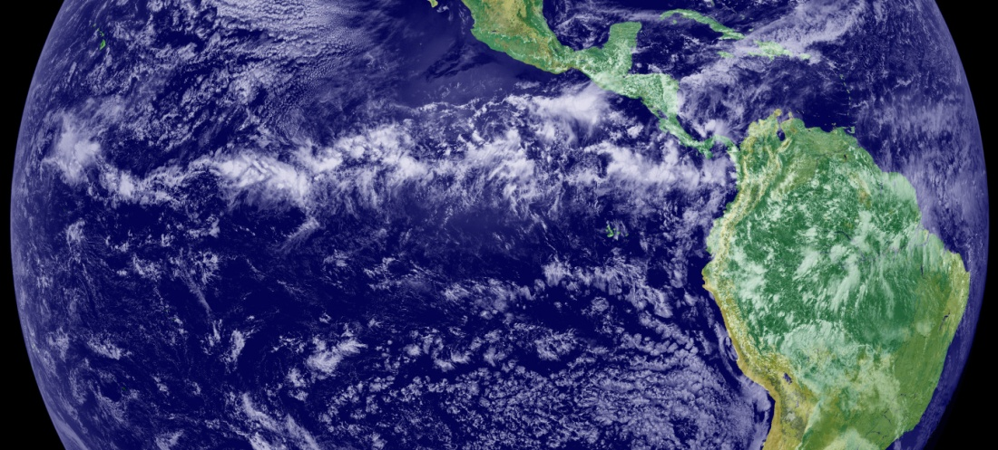
Ironically, the ICTZ's clouds shade the surface below the ICTZ zone and moisture originates just outside the ICTZ zone and raises due to the ICTZ thunderstorms. In the picture above the ICTZ is that horizontal band of clouds over Cali, Columbia (the city) stretching to French Guiana. The visible part of the ICTZ is over 12,000 miles (half way around the equator) long and about 300 miles wide.
This picture also illustrates a tail (corridor) of nearly saturated air leaving the ICTZ directly below the Baja peninsula of Mexico and extending across Central America, the eastern tip of Cuba and the Haiti/Dominican Republic to the East North East. That is a band of ICTZ moisture carried to a low pressure region.
The illustration here is of different hurricanes but demonstrates the tail coming up from the lower side of the radar and satellite pictures Because of the tail's high humidity it creates a trail of rain and thunderstorms allowing you to trace it from the eye back to the ICTZ.
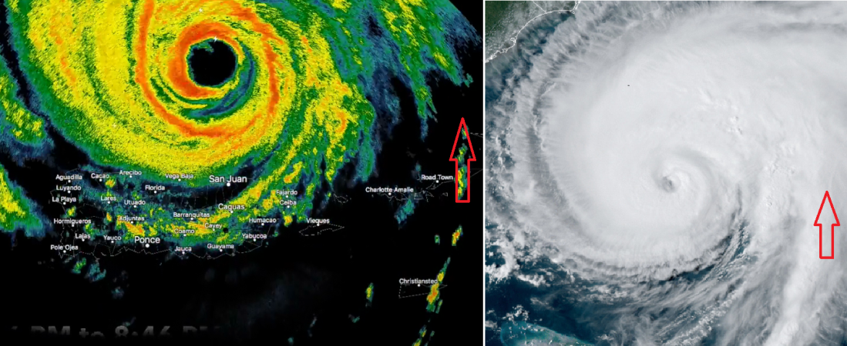
You will learn that hurricanes and low-pressure areas don't just look similar they are very much the same. The hurricane's tail is visible from satellite because it high moisture content results in rain as it travels toward the Polar Region. If you look carefully, you will find a tail for low-pressure regions.
One irony of an accurate detailed weather model is that the visible tail is due to air flowing parallel to the earth's axis because it resist's the Coriolis force causing a rise in the atmospheric corridor creating rain due to adiabatic cooling. If you understand that then you are on the track to understanding Earth's weather.
A hurricane's tail (marked with red arrow) originates from near the ICTZ and wraps around the hurricane a few times before delivering the ICTZ air tangentially to the hurricane eyewall thunderstorms. Its rotation is the result of interaction between fronts just like ordinary low-pressure regions.
There are actually two relatively parallel tails, one contains dry cool dense air and the other warm-moist buoyant air. In radar images the buoyant air has the rainfall. Therefore, an eddy's visible tail is associated with the higher moisture content side of the eddy. Hurricanes and low-pressure regions are eddy swirls that become visible because of high humidity ground level air rising to become visible as the humid air rises to cloud level.
Hurricanes originate due to physical interaction between the Oceanic Atmospheric circulation (OAC) of the oceans and the ICTZ as they pass each other side by side. Middle latitude lows originate due to physical interaction between southbound dense weather fronds and northbound buoyant weather fronts.

Eddy creation
Keep in mind that the atmospheric corridor effectively creates a high aspect ratio containment system. Nearly infinite x and y (horizontal) movement and limited z (vertical) movement creates a nearly two dimensional environment for atmospheric travel.
Eddies originate along the shear line where two fluid flows of differing density contact each other. The low-density fluid is warmer and therefore contains higher-velocity molecules due to thermal effects. The thermal velocity adds to the buoyant liquid's transit velocity. The outward pressure (statistically) of high-energy, low-density fluid creates a barrier between the two fluids as higher momentum buoyant molecules displace dense molecules along the plane of contact. This outward pressure counteracts the higher gravity induced pressure of dense air molecules, which would otherwise invade the buoyant flow.
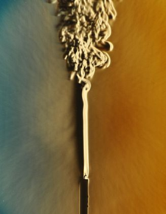
In the visible 3d world this is the reason a vertical candle plume remains laminar close to the flame.
When the combined thermal energy and stream velocity becomes great enough, the buoyant molecules break out of the laminar flow regime. This is NOT intuitively obvious. Without considering the thermal and stream velocity the dense air would be expected to invade the buoyant air's domain.
When examining the next set of panels remember that in the atmosphere dense air and buoyant air intersect each other at oblique angles, but the analogy is still accurate because the at a micro level the streams will be affected by each other forming a nearly parallel stream condition as depicted here.
Figure 1
In panel i, there are two streams passing without disturbance. Let's assume that the light colored fluid is low-density air moving toward the right (it could also be stationary) and the dark color is high-density air moving toward the left.
In panel ii, something creates a small disturbance that causes the right moving air to intrude into the left moving air's space. The alteration of one air's path will cause the other air to veer left into the other region as a response.
In panel iii, you can see that right moving air pulls formally left moving air past the original disturbance at A. The corresponding action happens to the other air stream.
In panel iv, you can see the beginning of a swirl.
In panel v, the swirl has completed a full turn and a half (540°) change in direction for both the heavy and light fluids.
The dark panel is closer to what you might see on weather radar. The cold front is coming from the northwest and the warm front is heading toward the northwest.
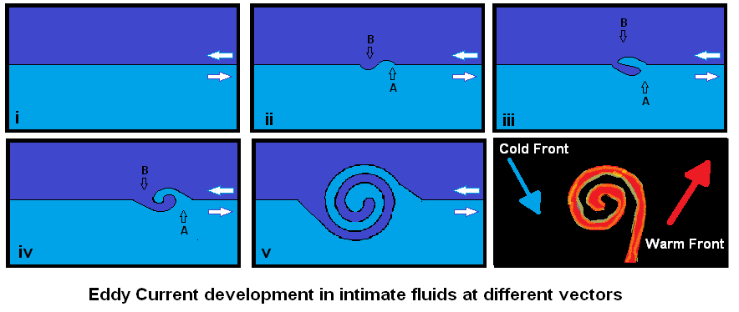
In panel v, if you concentrate on the left moving stream, it seems that it is the swirling component. Conversely, if you concentrate on the right moving stream it seems that is the one swirling. The important point is that both the streams are involved to a greater or lesser extent. It is generally true that the lesser density stream will exhibit the greatest deformation (intrude into the denser stream.
Figure 2
Let's face it, surface lows (the only kind) are eddies and eddies are cyclones.
This is also how hurricanes organize. The humid air is stationary (relative to the earth's surface) and dense air is traveling west. Humid air (stationary) invades the west moving dense air and invades its domain, which is north of the humid air. The thunderstorms begin because the northward motion of air will always be upward with relationship to the earth's surface in order to maintain the same distance from the earth's rotational axis. Rising air means rain and/or thunderstorms.
Isn't it interesting what you can learn if you take the trouble to understand what terms like Coriolis xxxxx means and how it works?
This mechanism works for hurricanes that begin on the southern westbound leg of the Atlantic Atmospheric Circulation. The AAC is the dense air moving westward and the relatively quiescent, ICTZ zone is the humid stationary fluid.
This is analogous to rolling a can rolling on a flat surface. If you push the top of the can to the left on the flat surface, the can will turn counter clockwise as you push the top of the can with your hand. This is a major cause of North Atlantic hurricane development.
Do you want to know how hurricanes start in the American Gulf? Get a copy of the next edition of the book, I'll have figured it out by then.
The last panel is sort of representative of eddy current development of TWF fronts as seen on a radar set. The cold front is cold-dry, dense air arriving from Canada via the Great Planes and the warm front is buoyant air leaving the Caribbean for England.
They don't approach each other at 180° angles, but the cold front still slows the northwestern edge of the warm front causing it to slow and turn toward the cold front. Some of the cold front's air also slows due to contact with the warm front causing it to vector toward the northeast.
If the colors were white on blue instead of red/yellow on black, this is what you would see from space as in the case of a weather satellite. The only visible indication of the fronts is areas of condensed water (contrail) where the two fronts 'rub' (contact) each other. The only visual indication of the fronts is condensing humidity from the warm-humid buoyant air of the warm front, therefore all you see is the cold front.
"Woah, wait a minute, stop, hold it," you cry, "that is NOT what you see over a hurricane!
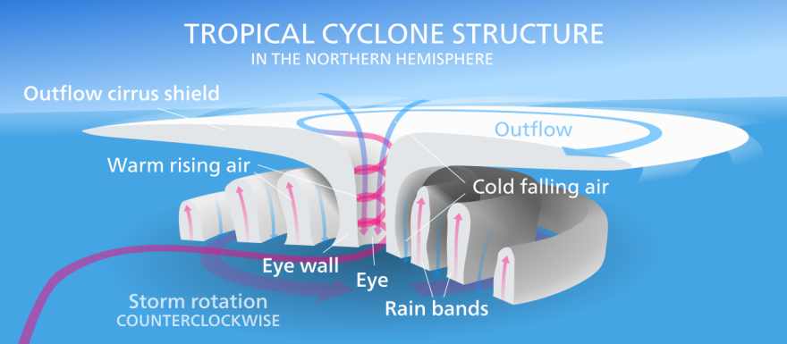
True, there is a unique flow caused by thunderstorms air rising in a hurricane's eyewall. The rain falls and pumps a lot of upper level air with it creating a curtain of falling air around the interior eyewall. That falling air came from at least the upper troposphere and starts out as cold, and I mean really cold (-55 °C) dry air. The air heats adiabatically as it drops and would be nearly at ambient temperature as it reaches sea (ocean) level - but - on the way down it mixed with turbulent rain driven thunderstorm air. I haven't done that calculation yet, let me know if you do. The falling air displaces air that was in the eye of the storm and it rushes up and out. That displaced air was warm humid which will adiabatically cool as it rises causing condensation which becomes the mushroom top over hurricanes. That's why the only detail you can see from outer space is the mushroom and the eye.
I told you ... science if fun, really fun, if you go at it seriously.

Normal front action
In all front interaction the cold dry dense air of the cold front is heavier and below a certain velocity will wedge under the warm front's warm-humid buoyant air. All pilots are taught this. They are also taught that when the buoyant air is under the dense air they just entered dodge and to get the hell out. The buoyant air of the warm front containing the available moisture creates the telltale counterclockwise signature of a cold front, or a hurricane or even a tornado.

Weather Coriolis Effects
Another poorly understood and incorrectly applied effect is Coriolis Effects. There is no Coriolis force.
You will learn that unlike ocean water, air molecules travel freely. The Coriolis Effect does NOT cause oceanic currents because there is no force acting on an object with a significant freedom of motion.
When you get the basics right the particulars are obvious.
Fun, really fun.

Tornados
NOW we're going to have a blast, literally.

Forces exerted on air molecules by developing tornados are adequate to accelerate those molecules to double digit mph velocities in a few feet. Unlike the delightful whirling dervishes in our photo, nature's spinning dervishes are artifacts of vertical weather and thus powered by gravity. Differential density values of 10% create forces 10% of gravity. This is equivalent to accelerating the molecules by 0.10g or about the same acceleration as typical family automobile at full throttle.
You can envision a tornado mouth as the equivalent to a gravity source but pulling horizontally instead of down. Therefore, the mouth of the tornado attracts the air molecules. Just like gravity earth's gravity, it creates the greatest velocity to the lightest (least dense) air molecules.
Okay, here we go with the counterintuitive talk again. First, I say that dense air displaces buoyant air because gravity has more attraction for dense air. Now I'm going to tell you that the momentum of buoyant air arriving at the mouth causes tornado movement. Momentum (p) = mass (m) * velocity (v). Buoyant air is lighter and in a field will accelerate more quickly than dense air. This means that a column of buoyant air accelerated from a standing start will arrive at a force source first because it accelerates quicker than dense air. The kinetic energy of matter (KE) is m / v^2. Now here is the tricky part the dense molecule is exactly like the buoyant one! There is just more space between the buoyant molecules increasing the volume of an otherwise fixed number of molecules. I did say gifted high school students!
There is another consideration. The buoyant molecules gang up on the dense molecules and once a corridor of flowing buoyant molecules is established they won't let the dense molecules enter. This causes dense air into a tornado to travel through a corridor into the tornado's mouth, the m/v^2 attraction thus becomes a m/v attraction causing greater acceleration of the buoyant molecules. Since the buoyant molecules, which have the same mass as the dense molecules are traveling faster their arrival at the tornado's mouth creates a momentum vector away from the source of buoyant air. That momentum vector is the result of molecules of almost exclusively buoyant air with fewer dense air molecules moving toward the tornado.
Theorem: Tornados move away from their source of buoyant air.
That statement is consistent with your life experience. The lighter car will win a drag race between cars with the same horsepower.
In this book, I go a step farther and posit that once established a channel for inflow air tends to sustain itself in place. I further posit that tornado inflow air can only enter the tornado from ground level. I further posit that even if the tornado 'walks' (moves it inflow mouth) the inflow channel will tend to remain in place. That is three theorems regarding tornado inflow air and there is no reason to stop there.
I farther posit that inflow air can only be tangential to the tornado's eye wall.
I further posit that the effective inflow tangential entry point will always be to the right side of a line drawn between the air source and the cyclone's vertical axis. (The actual inflow entry point to existing cyclonic air will be further around the cyclone but the inflow air is 'captured' by the cyclone at the tangent line mentioned above.
That is another three theorems regarding tornado inflow air for six theorems regarding tornado inflow air. My understanding of tornados is non-trivial. I've given all the reasons to support these theorems in this chapter.

Hurricanes
Hurricanes consist of an inflow air source, outflow air, and an eye. The eye consists of a circle of thunderstorms, an updraft of dry warm buoyant air, and a down draft of cold dry air as you progress from the outside toward the inside of the hurricane's eye. You read that correctly there are two inflow air sources and two outflow air sinks.
The hurricane's power is derived from hot, humid buoyant air from the ICTZ traveling through a tail (umbilical cord) that stretches from the ICTZ to just outside the eyewall no matter where the hurricane goes. Thunderstorms usually encircling the eye multiple times. The low-level buoyant air from the ICTZ rises through the thunderstorms due to its buoyancy and exits vertically.
Centrifugal force causes sorting of air with visible water droplets to be on the outer edge (including thunderstorms), humid air without visible droplets and invisible dry air as the inner layer. The inflow tail provides visible droplet air and humid air, however the invisible dry air is sourced from above the hurricane. When air with visible droplets reaches the top of the eyewall it spreads out in a 360 mushroom cap covering the inflow tail. When humid air reaches the top of the eyewall it is 'flung' out by centrifugal force but its reduced density (no embedded visible water drops) causes it to rise higher than the visible toadstool cap.
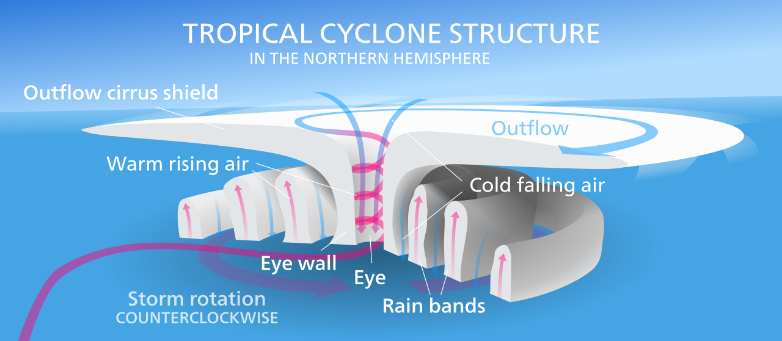
Rising visible droplet air and humid air in the eyewall 'pumps' upper level air from the bottom of the interior eyewall straight up out of the hurricane's eye. Since it is a cyclonic wall, I predict that the invisible dry air recirculates back into the center of the hurricane's eye.

Hurricane Genesis
One attribute of Coriolis Effects is their delaying action during the formation of a hurricane. Atmospheric Coriolis Effects are due to accelerating suspended air molecules at a moving target especially in the case of a potential hurricane. The air molecules don't 'swerve to the east' when a start-up tornado 'pulls' the air molecule toward its mouth but they do prevent the umbilical from following the hurricane west due their eastward translation. An air molecule accelerated by a force generated a minute earlier will continue to travel in the original direction of that force. Meanwhile, the source of force (tornado mouth) is moving west at a few miles per hour. We established earlier that buoyant ICTZ molecules will travel within an established corridor from their source to the mouth of a hurricane. Inflow air air moves north until it gets on the same latitude as the hurricane but since the hurricane is still an attractive force the hurricane's umbilical will overshoot the latitude and begin to swerve to the left toward the current position of the hurricane beginning the first loop of travel around the eye. As the umbilical chases the hurricane east it will again catch the hurricane and overshoot its longitude (this time) and swerve back toward the hurricane's current position.. It keeps circling until its contents flow into the hurricane eyewall.
NASA's depiction above is fairly close to hurricane operation. Things I would improve are:
- Inflow air is through the 'Rain Bands'. The depiction above has inflow air going directly into the eyewall, and even inside the thunderstorms.
- There is a single 'Rain Band' and it connects between the tail and the ICTZ.
- The warm rising air near the periphery of the hurricane's eye is only warm at sea level.
- The unlabeled blue air exiting from the eye is part of a loop with upper level air falling into the center of the eye and the unlabeled blue air coming out.
- When the tail is wrapped around the hurricane it captures cool side non-inflow air between the 'Rain bands'. That captured cooler-dryer air non inflow air is ejected vertically outside the eyewall thunderstorms and creates the space between the top of the 'rain bands' and the bottom of the outflow cirrus shield (toadstool cap).
Other than that, the diagram is quite good.

Top driven thunderstorms.
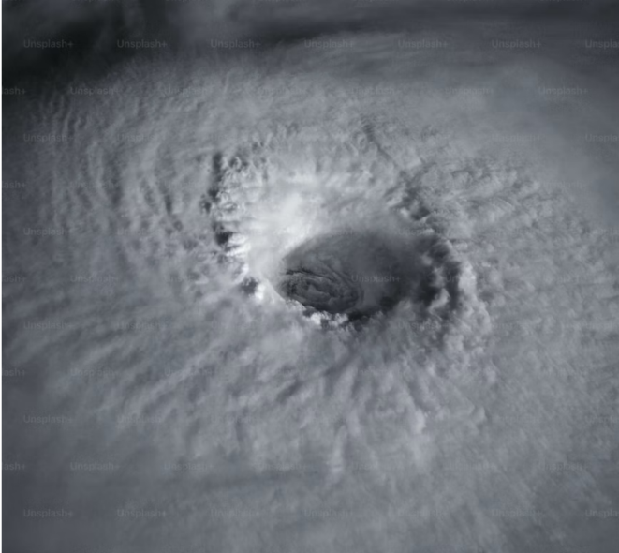
We aren't through with the hurricane's energy budget. Water's differential density doesn't account for the quantity of water a hurricane pumps.
Let's look at a hurricane is a slightly different manner. It is an air corridor from sea level to the upper atmosphere. Air's differential density and gravity power it.
The vertical velocity of a hurricane eye wall is such that it flings visible water droplets well above the troposphere. Those droplets don't immediately condense into rain because the air escorting them still resembled the ground environment. The result is a circle of thunderclouds circling the eyewall. To the extent they rise above surrounding water droplets they gather energy from the sun. Since the eyewall is miles high and miles wide the energy gathered at mid afternoon is immense. Thus the thunderclouds heat and become more buoyant causing them to rise, sometimes at over 100mph.
This above-cloud level energy capture is transported through cloud level via momentum. when the above cloud layer atmosphere becomes more buoyant it rises and is replaced by buoyant air from below causing a vertical column of air movement. This results in bottom driven (ITCZ buoyant air) and above (Thundercloud buoyant air) turning the tropical storm nuisance into a beast.
Please pay particular attention to the shadows in this photograph. The eye is dozens of miles wide. Therefore, the shadows are dozens of miles long and miles high. As you can see this is a late morning or early afternoon shot.
The solar energy for a single square mile of vertical cloud is
$$5,280 * 5,280 = 2.7 X {10}^{7}{ft}^{2}* 100 \frac{W}{{ft}^{2}}=2.7 X {10}^{9}watts$$
This is approximately 3 nuclear reactors per vertical square mile of exposed cloud * cos(Θ) * η where Θ is the sun's angle from horizontal. In other words, the cloud structures above the eyewall thunderstorms gather thermal energy equivalent to scores of nuclear reactors, which heats the thunderclouds resulting in increased lifting power within the storm's eyewall.
The same afternoon solar side heat can enhance the lifting power of tornados by the equivalent of a couple of nuclear power reactors.

Humidity background
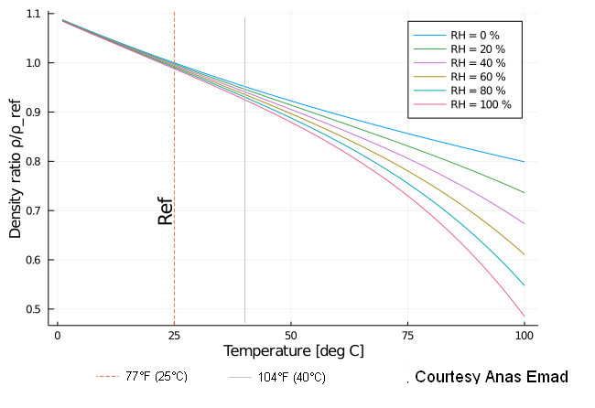
I hope I've convinced you that atmospheric density is responsible for vertical and horizontal air movement.
The characteristic of air causing its movement is its density. The two primary mechanisms affecting air density are temperature and humidity. Air density changes density in proportion to its temperature in terms of absolute temperature, in other words proportion to its Rankine or Kelvin temperature. A temperature change from 80°F to 120°F will certainly be very uncomfortable, but in absolute temperature it is only
$$\frac{\left(120°F - 80°F\right)}{\left(80°F +459.7°F\right)}= 7\%$$
or
$$\frac{\left(48.9°C - 27.7°C\right)}{\left(27.7°C +273.2°C\right)}= 7\%$$

Air density also changes dramatically according to amount of humidity (gaseous water) it contains. Water is a lighter molecule than air making air lighter (less dense) as humidity increases.
Interpolating from the temperature/humidity chart above, another 4% of differential density is added if you change humidity from 20% to 100% over the same temperature range, The 11% differential density is a conservative (less than possible) estimate of springtime differential density.
Water only exists in air at above its freezing point of 32°F the temperature at which liquid water freezes. Between 32°F and 212°F water can exist in the atmosphere with varying amounts of gaseous and liquid water. Atmosphere with only gaseous water is normal. Atmosphere with barely visible water droplets is contrails, clouds or fog. Atmospheric water with larger size droplets is rain.

Temperature and Humidity
Air temperature is the primary reason for atmospheric air density when temperatures are below about 75°F (14°C). The combination of temperature and humidity created density differences above that temperature.
Technically air density is very complicated because it is not linear when humidity is a factor. Humidity becomes a factor at temperatures above the melting point of ice 32°F (0°C). The curves in the illustration above reflect the non-linear relationship. When temperature alone is responsible for differential density such as in the winter the availability differential density (available force) is small. When both temperature and humidity are responsible for differential such as in the summer, the available differential density (available force) is much larger.
Mathematically, the relationship between density, temperature and humidity is non-linear. I've drawn two vertical lines in the chart above. The Ref line is room temperature and the light grey line is 104°F (40°C) a high surface temperature. At 77°F (25°C) humidity contributes about 1.5% to air density. At 104°F (40°C) humidity contributes about 6% to air density. The total density difference in density is about 8% between 77°F (25°C) and 104°F (40°C) which is enough differential density to create a small tornado or very windy thunderstorm.

Solar orientation
The earth's rotation, its orientation to the sun and its orbit of the sun drive weather effects. Spinning of the earth on its axis provides daily variations in heat. The tilt of earth's axis to the solar plane provides different heating levels in its northern hemisphere or southern hemisphere. The annual progression of the earth around the sun changes the orientation of the earth's rotational axis to the sun.
The two equators are the solar equator and the geographic equator, an imaginary line equidistant from the two poles of rotation. Solar equator is the line of points formed when the sun is directly overhead at noon. Equinox (about March 20 and September 22) is when the solar equator and geographic equator are in the same place on the globe. At equinox day and night are of equal length and the sun is overhead at noon at the equator.
Earlier we discussed that the solar equator is affected by earth's tilt from the solar plane because there is little TWF near the physical equator. As you get away from the physical equator seasonal change are much more significant. During summer months, both the sun angle and the length of day changes, nearly doubling available heat in the mid latitudes.
During Summer Solstice (about June 20) the solar equator is 23.4° south of the geographic equator and during Winter Solstice (about December 21) the solar equator is about 23.4° north of the equator.
The longer days of summer heat the northern hemisphere more than the southern hemisphere. The shorter days of winter heat the northern hemisphere less than the southern hemisphere.
During non winter months much more humidity is available to the atmosphere over land and the effects of humidity on differential density are very much greater.

Topology
Earth's topology provides an extremely complex heating and cooling profile to the atmosphere. The land mass of Russia and Canada and to a lesser extent Asia and North America dominate the northern hemisphere. The land mass of Brazil, southern Africa and Australia dominates the southern hemisphere. The northern hemisphere is mostly land and the southern hemisphere is mostly water.
Later I will discuss how nearly all 'normal' (non-extreme) weather occurs in the lower atmosphere. I will also posit that all significant movement of atmosphere occurs in the lower atmosphere. This is a radical departure from current weather theory.
Earth's topology affects weather because mountains 2,000' or more above surrounding terrain strongly affects weather patterns, which is to say the direction of airflow. In North America, the Pacific Mountains provide a significant, but penetrable barrier to Pacific Ocean weather, while the Appalachian Mountains provide a weather vane to move atmosphere into northern Europe. Southern European Mountains shield the Mediterranean area from Arctic cold. Asian Mountains funnel Arctic cold to Korea and Japan and into Alaska and Canada.

Diurnal moisture pump
The atmosphere is a relatively efficient daily moisture pump powered by daily variations in solar radiation, which, from a ground observer's perspective, moves from east to west. Of course, the movement is the earth's surface traveling from west to east with respect to the sun. But how often do we non-astronauts get to observe from the sun's perspective?
Oceanic air maintains a more constant temperature than land air. Diurnal solar movement begins with the sun rising in the east.

Phase 1 Morning hours
The ocean is at about the same temperature as it was when the Sun set in the west. Land temperature is probably cooler than water temperature at sunrise. Cooler land surface temperatures cool the air resetting the diurnal 'pump'. As the day progresses, solar heat does little to change the temperature of air over the water but cool air over land heats very quickly and on most days gets much warmer than air over water.
As the sun comes up, air over land heats quickly day compared to over-water air. As a result, the over-land air becomes more buoyant causing it to rise in the atmosphere. As buoyant over-land air rises, moist over-water air replaces it. The result is that humid over-ocean air moves over land.
The previous day moisture is moved scores or even hundreds of miles to the west each day.
That injection of moisture is the primary source of continental east coast air. Its moisture inundates the rain forests of Brazil and Eastern Asia as well as making the U.S. southeast, Australia's east coast and much of Africa's east coast fertile.

Glare Factor
The glare factor (defined and discussed elsewhere) accentuates this effect. Sunlight does not penetrate the water until about mid morning. Sunlight bounces off water surfaces and back into the atmosphere before mid-morning. This is the glare effect. During the morning radiant energy striking a land mass is absorbed while light striking the ocean reflects, significantly increasing the ratio of earth atmosphere heating to ocean atmosphere heating. This is also true of afternoon sun, but another effect dominates weather at that time of day.
The angle of incidence for ocean water is about 48° meaning that at equinox the oceans are only absorbing solar radiation between 10 A.M. and 2 P.M. or about four hours per day at the equator. At higher latitudes, the time decreases. Glare reduces available absorption time greatly during winter months with virtually no oceanic solar energy absorption above latitudes of about 30° (Jacksonville, FL).
I'm guessing that you read it here first.
It is important to note that the ground absorbs heat at the surface because it is opaque. Nature optimizes plant life to absorb visible light efficiently. Soil is a near black body because photons bounce back and forth on the uneven surfaces of the ground until they are absorbed as heat. Plant life and soil also have low heat storage capacity. Any heat absorbed by plant life or soil transfers to the atmosphere immediately making it more buoyant.

Heat entering the ocean's surface is absorbed well below the surface. Solar heating of the ocean surface is minimal. The picture illustrates the approximately 48° window for sunlight. It also demonstrates that sunlight that enters the water is absorbed well below the water surface.
Water is a medium conductor of heat much worse than a metal and much worse than a thermal insulator.
The oceans are either reflective absorbing very little solar radiation for the hours just before sunset and after sunrise or black bodies, absorbing all available light during the rest of the day. After the sun is high enough in the sky to penetrate water (exceeds the glare-effect angle), light travels deeply into water before it is absorbed. In other words, open water is a black body for radiation arriving vertically angles. During midday hours, the sun heats both water and earth. Both are nearly blackbodies absorbing most of the heat striking them.
Heat retention is an entirely different situation. Ground particles heat quickly because of their low mass and rough surface, but they also cool quickly because of their low specific heat and large surface area relative to water. Water absorbs solar radiation as heat and because of its high specific heat and depth of photon penetration distributes. Radiant heating of water extends below the surface. Because of water's large specific heat, its surface does not get as hot as the ground surface. Water has low surface area retaining much more of the heat it absorbs than ground.
While the sun is above glare angle, you could say that solar radiation striking the ground quickly heats the air while solar radiation striking the water surface stores heat down to about 30'. That is certainly how you would model the two surfaces for simulation purposes.

Humidity
Humidity increases buoyancy. Both plant respiration and photosynthesis create a lot of humidity. Simulating plant respiration is tricky because it begins when the seed germinates and continues until the plant is making enough sugar by photosynthesis to sustain itself. There is also a large difference in gas mobility in cultivated land as opposed to natural land.
It is also worth mentioning that spring plowing of large areas of land exposes moisture that would otherwise be underground to open air and solar radiation. This exposed soil can contribute large amounts of moisture to the atmosphere.

Plant Respiration
And, and this is a big one, respiration continues through the night creating oxygen and more importantly to this paper, humidity. This effect becomes very significant when you add plant life humidity to ground heat when computing atmospheric buoyancy. Reminder: Air movement is a function of differential air buoyancy.
Heat and humidity increases over land during the midday hours making the air buoyant. As humid air rises above cloud level it condenses making it visible and increasing absorption of sunlight energy.

Phase 2 Evening hours
By midday, inland air has established adequate buoyancy to penetrate cloud level. In areas with adequate moisture, the buoyant air also creates visible clouds. The western edge of freshly created clouds receives solar in mid afternoon causing them to rise. The western edges of clouds will lose enough condensation moisture to create rain. Falling raindrops are a very efficient air pump as they fall moving upper level air lower. Although rain pumps air downward efficiently, the rain will always reach the ground before the air because of the rain's low surface area to mass ratio. When the falling air reaches the ground it flows westward away from the advancing front of rain pumped air.
Notice the use of the term front. There are two types of front with similar appearance, namely an advancing wall of changed atmosphere. This front is the result of vertical (gravity driven) air movement causing air movement from a shoreline. The other front is the result of horizontal (TWF) air movement causing air movement between the latitudes. This is a case of vertical weather mimicking horizontal weather.
The first rain from the western edge of clouds falls on sun-heated ground. That first rain absorbs ground heat, contributing to ambient humidity. The increased humidity increases local ground air buoyancy as the ground cools. So high-level rain falls to ground level where it contributes to ground level humidity causing ground level air to rise pushing subsequent rain westward.
The result is a 'rolling' wall of increasingly buoyant air.
The sun heats the western side of clouds created earlier in the day. Adding heat to the western edge of the clouds makes them more buoyant elevating moist air further into the atmosphere. As western clouds rise, they cause lower clouds to the west to rise with them while starving lower clouds to the east of sunlight. The result is an apparent wave of clouds rising from east to west. Afternoon solar heating only affects the western edge of clouds. As buoyant clouds rise, air west of the clouds is involved causing an apparent movement of clouds.
By this mechanism moisture, in the form of clouds travel from east to west due to western cloud face heating. Visible clouds absorb solar energy, not dry air.
Droplets rise with the Sun heated atmosphere becomes more buoyant. The atmosphere cools adiabatically, but is still lighter than ambient air at the new altitude. Eventually rising clouds even further west or the setting sun removes the heat source allowing in-place cooling causing humidity to condense in the form of rain. Moisture condensation results in heating of remaining dry air increasing its buoyancy causing it to continue to rise out of the way and pull lower air higher thru inertial effects. As the rain cools the atmosphere, through which it travels and the ground on which it falls.
The shaded (eastern) portion of the west-moving cloud front cools and rain falls miles west of the location it evaporated. The next day that rain moved west will contribute to atmospheric moisture and fall at a more western location.
After the sun goes down the atmosphere resets by cooling and drying allowing air sinks after the sun sets. Unlike Florida's peninsula, each day is different so the mechanism is more of a trend than a fixed repeatable action.
This mechanism transports ocean and ground moisture west.
Daily solar heating pumps humidity from the east coast toward the west coast of continents. Daily weather variations are greater on the east coast of continents. Florida's summer variations include sun, rain and thunderstorms nearly every day. In the East Coast coastal low lands, rain is constant providing excellent growing conditions.
Nowhere is Diurnal Weather Fronts (DWF) more obvious than in peninsular Florida. During summer the sun rises in the east, the coastal winds begin their rush to Florida's interior, moisture is moved westward across the state arriving at the west coast at about rush hour in Tampa. The weather is so consistent that the police would position a car at Hillsboro and Armenia to reset the traffic light after the daily lightening strike.
India's topology is a gradually rising plane from the east coast to mountains on the west coast. Because of DWF India is one of the few countries that can feed itself without use of modern mechanization even though she is now the most populous country in the world.
Brazil is another country without mountains on the east coast as evidenced by its naturally irrigated rain forests due to DWF effects. Imagine all the folks Brazil could feed if they tilled the rain forests.
I will explain how weather DWF weather dominates weather on the eastern slopes of the Appalachians the western slopes are dominated by TWF effects as cold fronts push down the center of the country from the Arctic.
A line of mountains (Himalayas) to the south of China shields Southeast Asia from TWF effects making this the dominant source of weather, especially in summer. I have personally experienced the Asian monsoons as well as their more sedate Florida equivalent.
Don't you hate when at the end of a 10,000-piece puzzle there is that one missing piece? Even though I realize I was probably the one that lost the missing piece but that doesn't assuage my consternation. When I began this quest I wanted to understand tornados. After a few years, I was sure I solved vertical weather and horizontal weather but still couldn't understand southeastern Asia's weather, which I was privileged to experience in detail in 1968 and 1969.
DWF was the last piece in the puzzle I finally understood it after making a windmill efficacy study off the coast of Florida.

Author's note:The claim that Gulf water fuels hurricanes is often repeated, but doesn’t survive even basic physical scrutiny. Start with the water: hurricanes release tens of trillions of gallons of rain as rain. There simply isn’t enough local atmospheric moisture above the Gulf to supply that kind of output. Even if the Gulf air were fully saturated, it wouldn’t come close. Next, the energy: the latent heat required to evaporate that volume of water far exceeds what solar input can provide — and hurricanes aren't even sunlit. They're covered in clouds that block insolation and cool the surface, not heat it. Yes, sometimes hurricanes strengthen over warm water. They also strengthen over cooler water. There is no reliable correlation between Gulf surface temperature and storm strength. The idea sounds plausible, but it’s not backed by observation, thermodynamics, or scale. The real factors? Pre-loaded atmospheric moisture, organized structural flow, and large-scale forces like TWF that move air masses into configuration. Warm water is not the fuel tank. It’s just the stage floor.
Author's note: The particularly astute will recognize that a low humidity cold front was arriving for both Helene and Milton. Low humidity air would increase surface evaporation in the Gulf of Mexico but the low humidity air did NOT mix with ground level air near the hurricanes otherwise the rain bands (tail actually but we haven't covered that yet) would have disappeared. However, the cold front for Milton did create conditions for an outbreak of cluster tornados, which this theory predicted.
Shits and giggles.
Author's note: There are multiple reasons ocean clockwise rotation is not due to Coriolis Effects but the fact that the ocean is very viscous reduces its north-south movement meaning it is not intimately coupled to Coriolis Effects - especially near shore. The ocean surface, especially near shore, is tightly coupled to the atmosphere. Where the air leads the ocean follows.
Author's note: The author discovered this mechanism while studying the effects of off-shore electricity windmills.
Technically this is because soil and plant surface features have little thermal mass allowing them to heat quickly. Soil and plant surfaces have relatively large surface area to specific heat ratios allowing them to the atmosphere quickly.
Author's note: I discuss the glare factor elsewhere using the 48° value for the sake of argument because the discussion is about measurements in the ppm range. I'm much less particular about specifics when I'm addressing those that are less particular about specifics. Check out glare factor in the glossary for more specific information.
Author's note: Please note that the thermal pumping capability of the water-land interface is very high because water has high heat capacity and soil and plants have a low heat capacity. Soil and plants transfer nearly all heat they gather to the atmosphere immediately. In this way their ability to vertically pump air is maximized.

